# Exercise: Web Server – State Management

Problems for exercises and homework for the [“C# Web Basics” course @ SoftUni](https://softuni.bg/courses/csharp-web-development-basics). Yoy can submit your solution in the course web page.

Remember the app you made in the previous exercise – By The Cake? Now you are going to extend it with login/logout functionality and functionality about creating orders.

## Login Users

Create a Login page with simple form that asks for username and password. Since we are not using any database for now we are not going to register users. So the user will be logged in with any username and password.

After successful login the user should be taken to the home page **"localhost:{port}/"**.

If the user tries to access any page without being logged in, he/she should be taken to the login page.

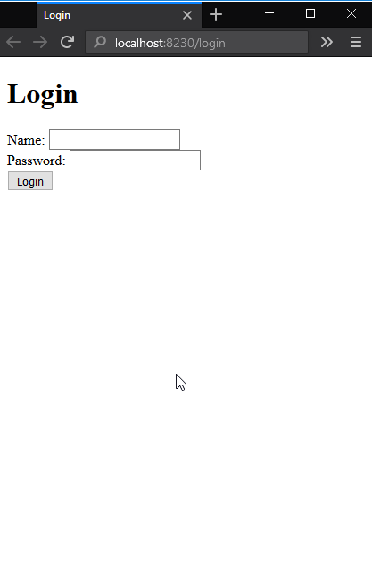

## Keep the User Logged In

After the log in the user should access any page of the application without being asked to log in.

## Implementing Cart

Extend the search page. Add a button "Order" next to each cake.

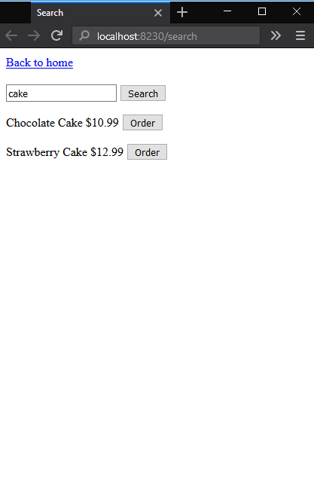

After submitting an order the page should show the count of ordered cakes. The link "Your cart" should navigate to a cart page.

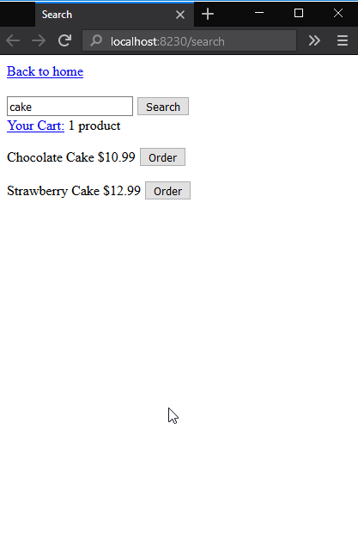

## Implement Cart Page

The cart page should list the ordered cakes and the sum of the order.

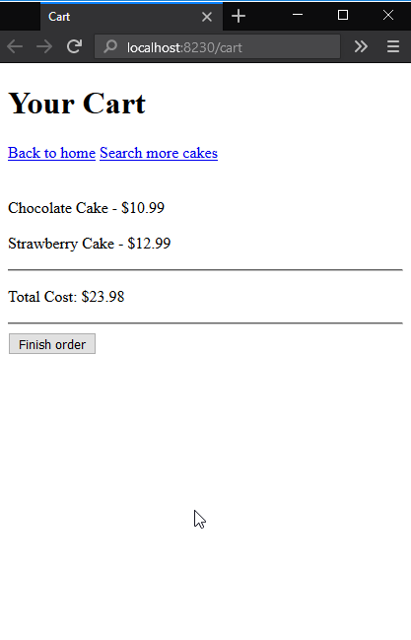

## Finishing the Order

The button "Finish order" should clear the cart and show a page with success message.

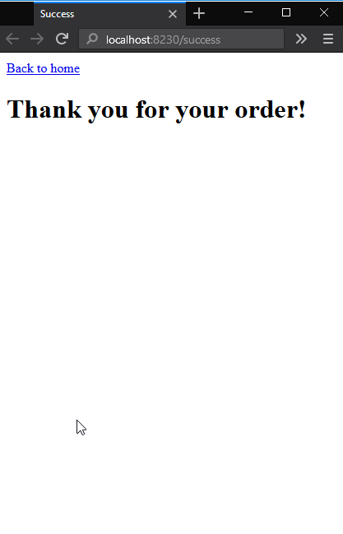

## Implement Logout

Add button "Logout" to each page. When the user press the button he/she should be logged out and the cart should be cleared.